**CENG 103 LAB 4 8.11.2016**

**1- Write a program that creates following output.**

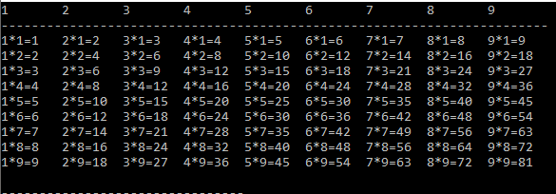

**2- Write a program that reads a series of pairs of numbers as follows:**

**a) Product number**

**b) Quantity sold for one week**

**- Your program should use a switch statement to help determine the retail price for each product.**

**- Your program should calculate and display the total retail value of all products sold last week.**

